Nama : Aulia Ikvanda Yoren

NIM : 6706160007

Kelas : D3 IF 40-01

JURNAL JRK 12

1. IP 192.168.100.102 (Divisi B)

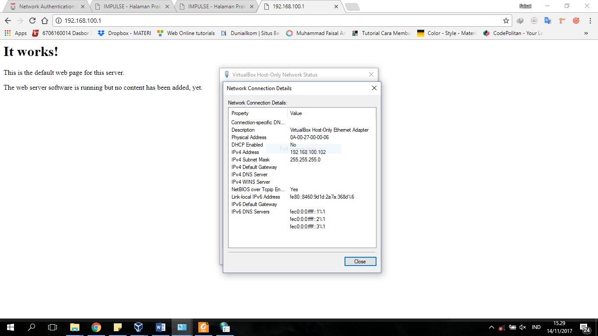

IP 192.168.100.2 (Divisi A Acces Denied)

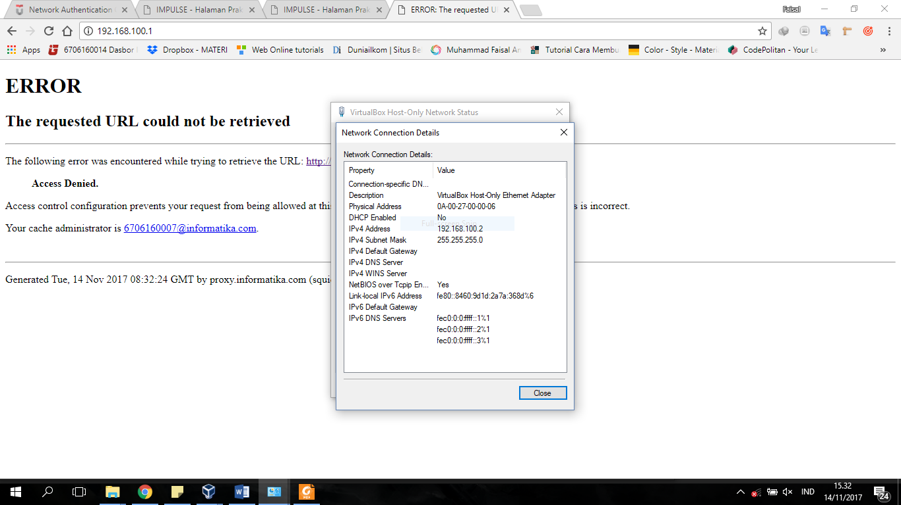

IP 192.168.100.27 ( Divisi A Acces Allow)

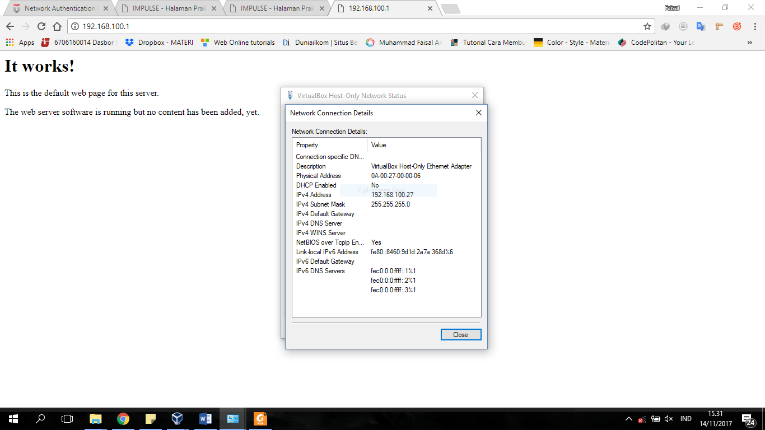

Config IP Squid

